Python Assignment 2 - Arthisree S R

1.Write a function which will return how many times a word (symbols separated with space, coma and dot) meet in the string.

Program

def word_count(str):

counts = dict()

words = str.split()

for word in words:

if word in counts:

counts[word] += 1

else:

counts[word] = 1

return counts

print( word_count('i am an indian.'))

Output:

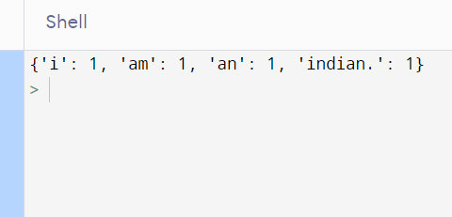

2 Write a Python function to get a list, sorted in increasing order by the last element in each tuple from a given list of non-empty tuples.

Program

def last(n): return n[-1]

def sort_list_last(tuples):

return sorted(tuples, key=last)

print(sort_list_last([(8,9), (7,6), (4, 4), (4,6), (3,2)]))

Output:

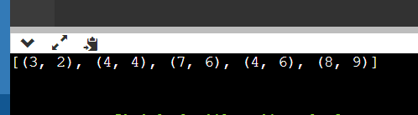

3.Write a Python program to sort a list of dictionaries using Lambda.

Program

models = [{'make':'iphone', 'model':128 , 'color':'sierra blue'}, {'make':'realme', 'model':'3', 'color':'Golden'}, {'make':'Samsung', 'model': 23, 'color':'Black'}]

print("Original list of dictionaries :")

print(models)

sorted_models = sorted(models, key = lambda x: x['color'])

print("\nSorting the List of dictionaries :")

print(sorted_models)

Output:

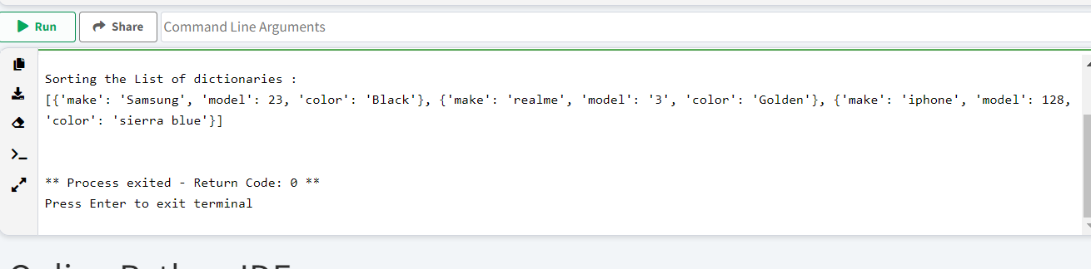

 4. Write a Python program to convert a given list of strings into list of lists using map function

def strings_to_listOflists(str):

result = map(list, str)

return list(result)

colors = ["Puink", "Blue", "Black", "Green"]

print('Original list of strings:')

print(colors)

print("\nConvert the said list of strings into list of lists:")

print(strings_to_listOflists(colors))

Output:

